Name: Key Class: Date: ID: A

Acids and Bases Practice Quiz

Multiple Choice
Identify the choice that best completes the statement or answers the question.

B 1. How is pH important during digestion?
a. Different enzymes work best at different pH values.
b. Digestion needs a constant pH to take place.
c. Different foods have different pH values.

B 2. Which is a characteristic property of acids?
a. They do not react with metals.
b. They turn blue litmus paper red.
c. They turn red litmus paper blue.

B3. Acids naturally present in food are safe to eat because they usually are
a. dilute. b. weak. c. strong.

C 4. If you have a solution of a strong acid and a solution of a weak acid of equal concentration and volume, then the
a. two solutions will have the same pH.
b. strong acid will have a lower pH.
c. strong acid will have a higher pH.

A 5. How does chemical digestion differ from mechanical digestion?
a. Chemical digestion requires enzymes.
b. Chemical digestion does not involve the stomach.
c. Chemical digestion is limited to grinding and mashing of food.

B 6. Neutralization is a reaction between a(n)
a. acid and a metal.
b. acid and a base.
c. salt and water.

A 7. In water, bases form
a. hydroxide ions.
b. hydrogen ions.
c. oxide ions.

B8. The process that breaks down complex molecules of food into smaller particles is called
a. conduction.
b. digestion.
c. neutralization.

B9. Acids are described as corrosive because they
a. taste bitter.
b. “eat away” at other materials.
c. turn litmus blue.

B10. Normal rainfall is slightly acidic, which means its pH must be
a. between 7 and 9. b. between 5 and 7. c. less than 2.

A11. What does a neutralization reaction produce?
a. water and a salt
b. acids
c. bases

B12. The pH scale measures
a. the strength of an acid.
b. the concentration of hydrogen ions.
c. the strength of hydrogen ions.

C13. In a water solution, how do acids differ from bases?
a. Acids form salts, bust bases do not.
b. Acids turn litmus blue, while bases turn litmus red.
c. Acids form hydrogen ions (H+), while bases form hydroxide ions (OH–).

C14. You can find the pH of a substance by using
a. a thermometer.
b. a conductivity tester.
c. litmus indicator.

B15. Compared to the pH of saliva, the pH of stomach juices is
a. the same.
b. lower.
c. unpredictable.

B16. Which is a likely use for a base?
a. as a vitamin in your food
b. making soaps and detergents
c. etching metals for printing

Modified True/False
Indicate whether the statement is true or false. If false, change the underlined word or phrase to make the statement true.

Word Bank
True True
True acid hydroxide
True chemical more True closer stomach True foods

T17. Mechanical digestion tears, grinds, and mashes large frood particles into smaller particles.

T18. A salt is an ionic compound produced from the neutralization of an acid with a base.

T19. Acids and bases have many uses around the house and in industry.

F20. Bases form hydrogen ions when in a solution. Hydroxide

T21. When the pH is high, the concentration of hydrogen ions is low.

T22. Acids are corrosive.

F23. A(n) base is a compound that tastes sour and reacts with some metals. acid

F24. Digestion breaks down enzymes into simpler substances that your body can use for raw materials and energy. food

F25. At the same concentrations, strong acids produce less hydrogen ions than weak acids. more

F26. In a reaction of an acid with a base, the pH changes to a value that is further closerfrom neutral.

T27. A base is a compound that turns litmus blue and is often found in soaps and detergents.

F28. Mechanical digestion happens with the help of enzymes that are sensitive to pH. chemical

F29. The organ with the most acidic contents in the digestive system is the liver.
stomach
Short Answer

Use the diagram to answer each question.

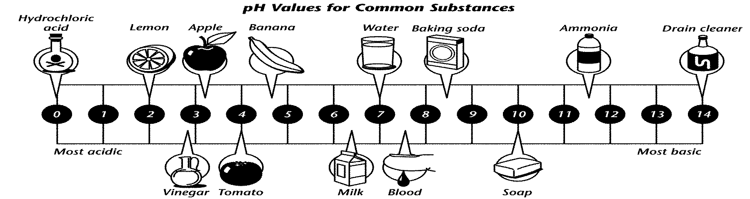

30. What color would litmus paper turn in a solution of vinegar? Explain your answer in terms of pH.

Red litmus paper stays red and blues litmus paper turns res because pH is low for an acid.

31. Use the pH scale to compare soap and drain cleaner.

Soap has a pH between 9-10 while drain cleaner has a pH that is higher (14 and up)

32. In terms of pH, explain what would happen if you mixed lemon juice with a solution of baking soda. What type of products would form?

Neutralization would occur producing salt and water.

33. What does the pH of water tell you about how the water differs from the other items shown in the diagram?

pH is neutral at 7.

34. Why would you expect tomato juice to taste sour?

Tomato juice is sour because it is an acid.

